**Task 1 – Integrate and Run medusa locally**

**Step - 1:**

We have to install the prerequisites for this task. They are-

* Git
* Nodejs
* PostgreSQL

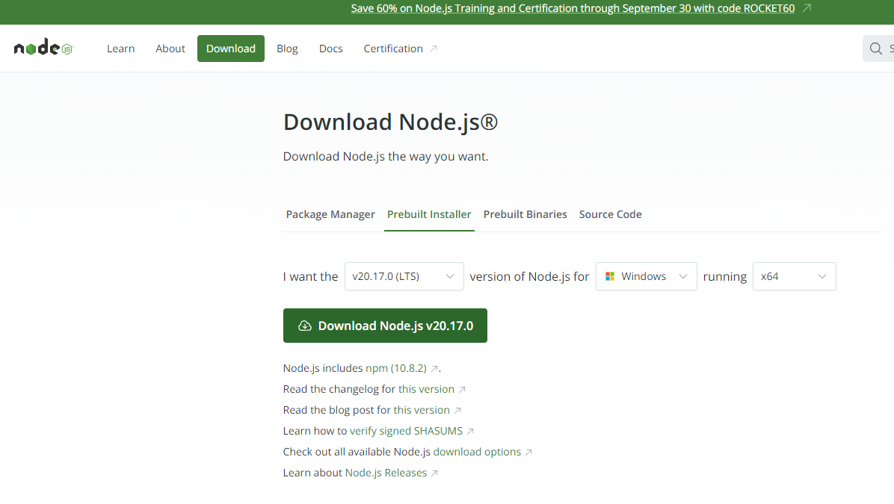

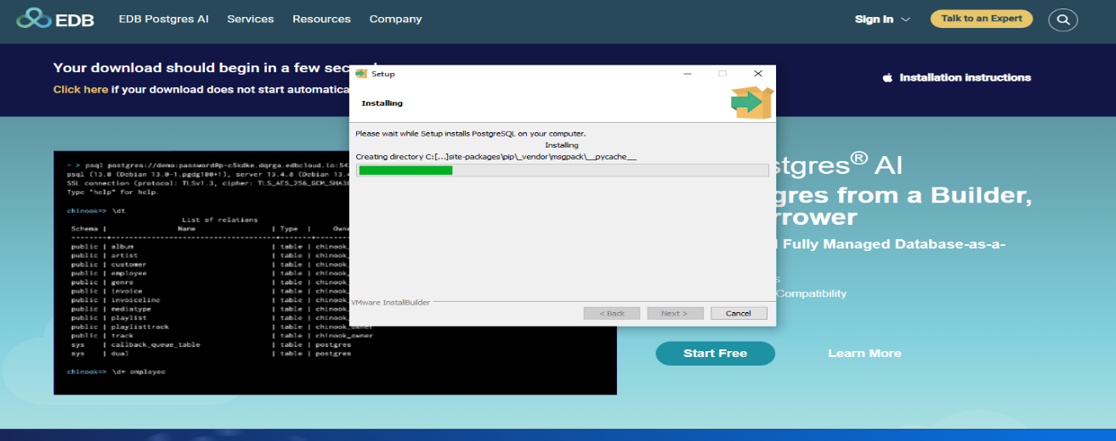

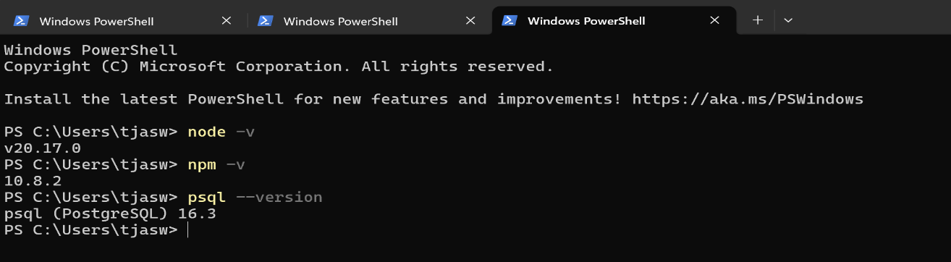

**Step - 2:**

Now we have to install the Medusa cli.

we use this command for installing cli -- npm install -g @medusajs/medusa-cli

Note: Check the medusa installed or not by using command ---- medusa -v

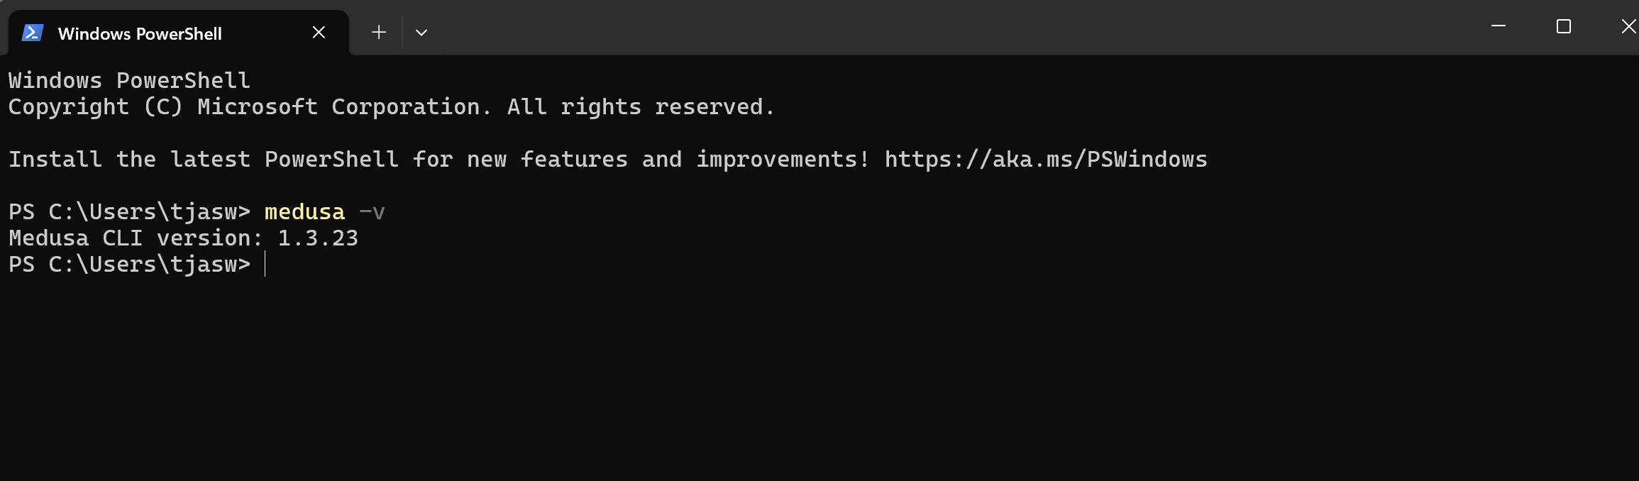

Step – 3:

Now we need to create app in local by using medusa cli command – medusa new <application-name>

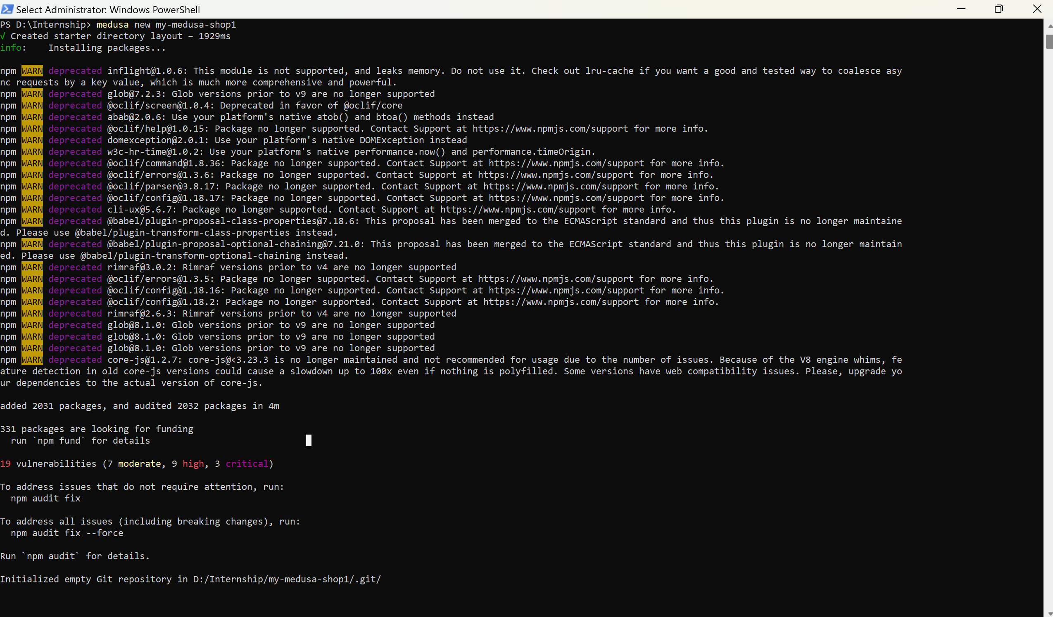

Give the details of your database usename, password and all the details.

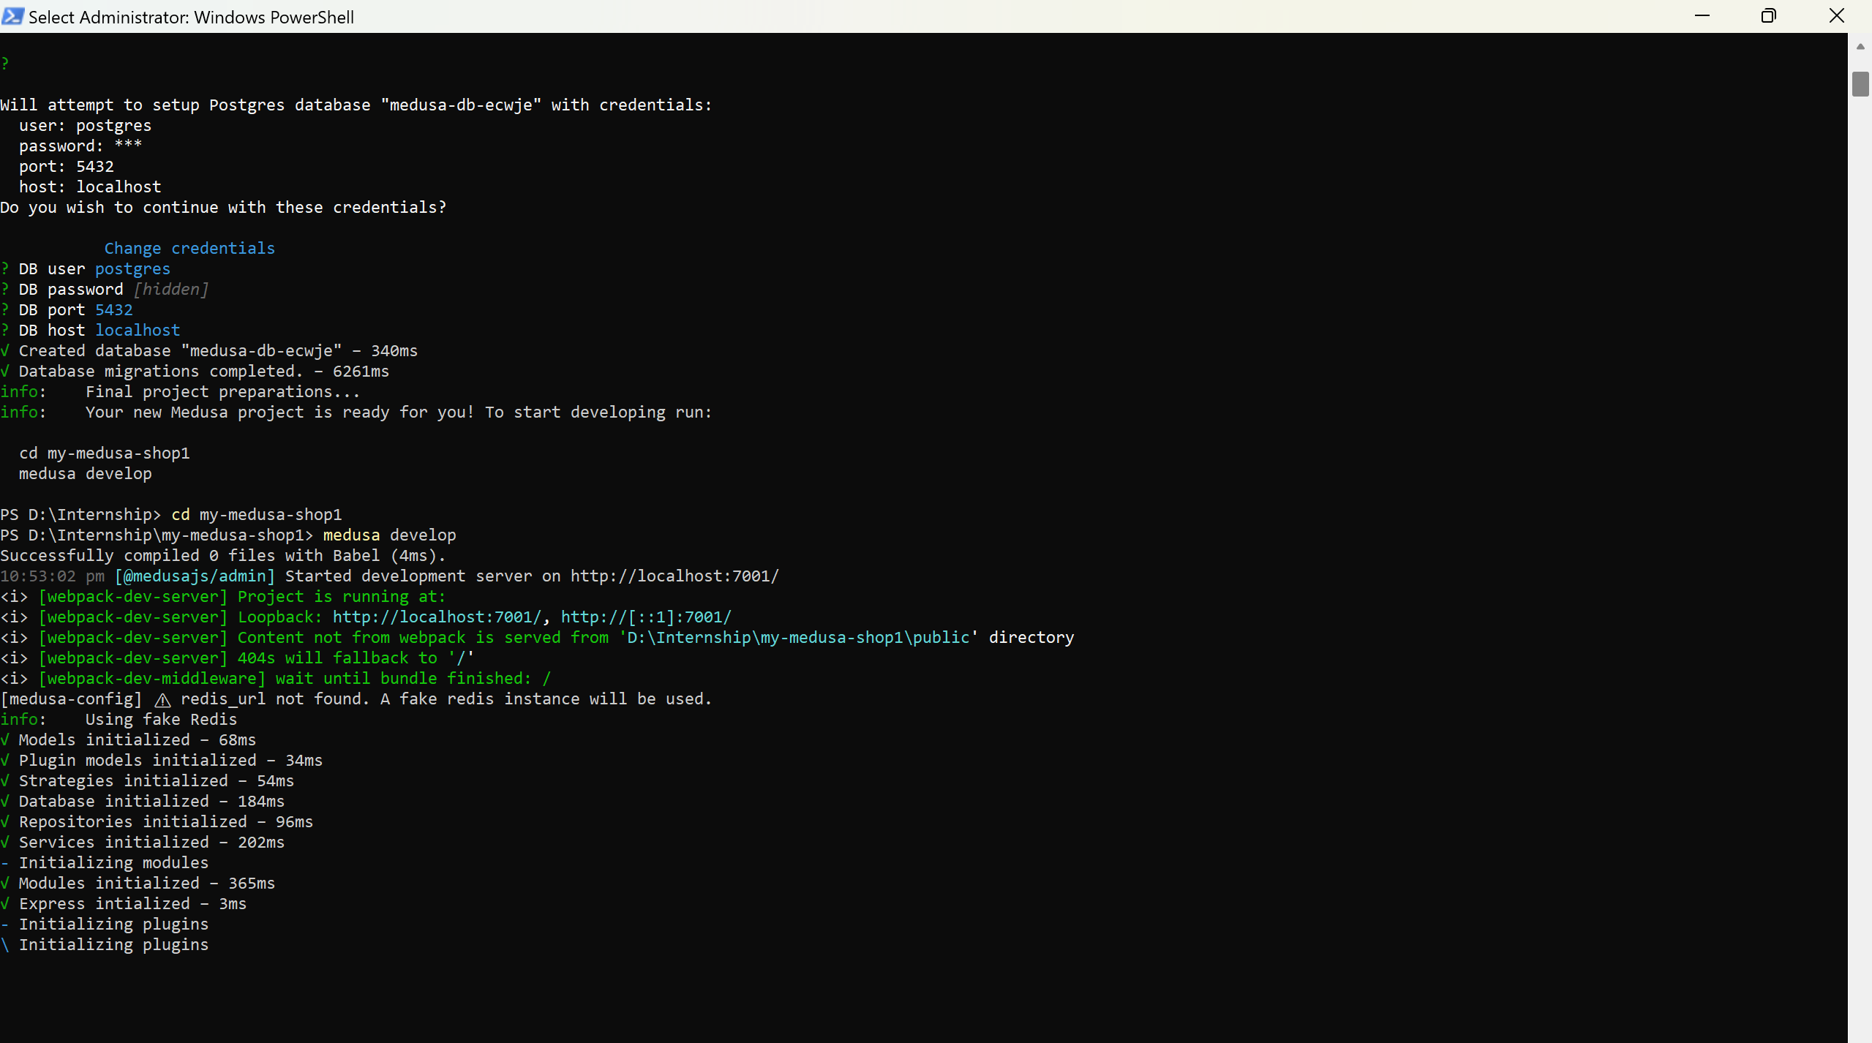

**Step – 4:** Change the directory to your application name using command – cd <application-name>

Then, Perform the develop command to build and run the application --- medusa develop

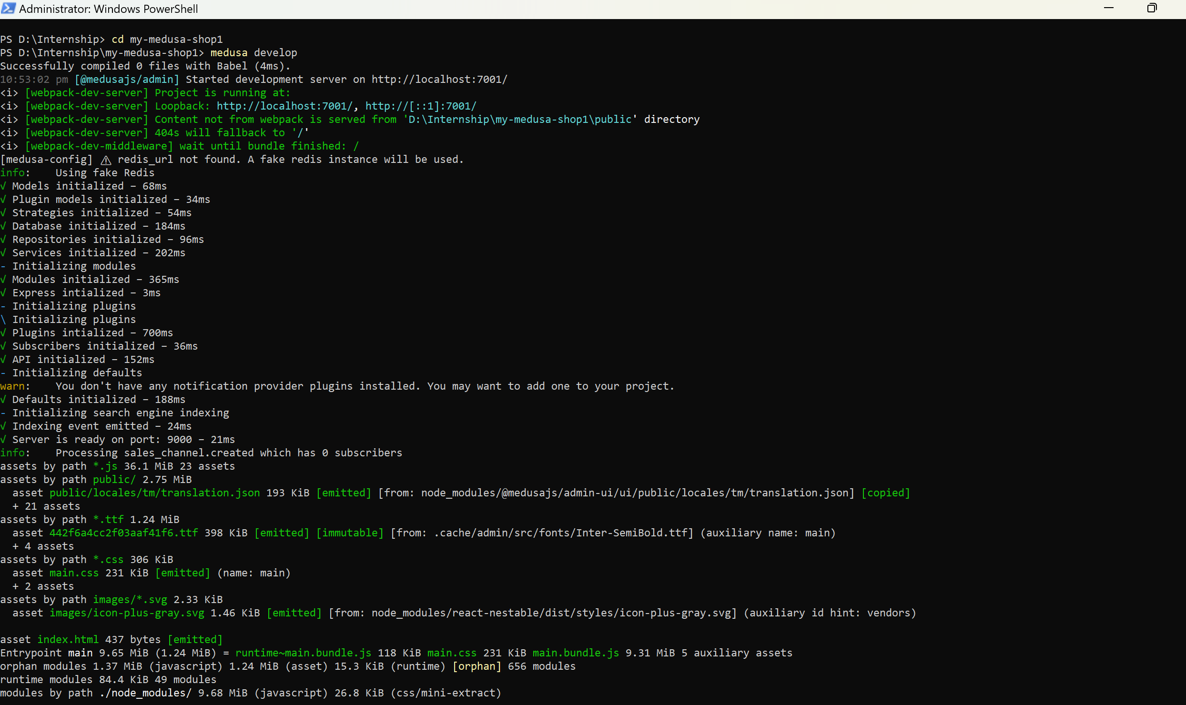

**Step – 5 :** You can access the application on the localhost port by using the link

<http://localhost:7001/login>

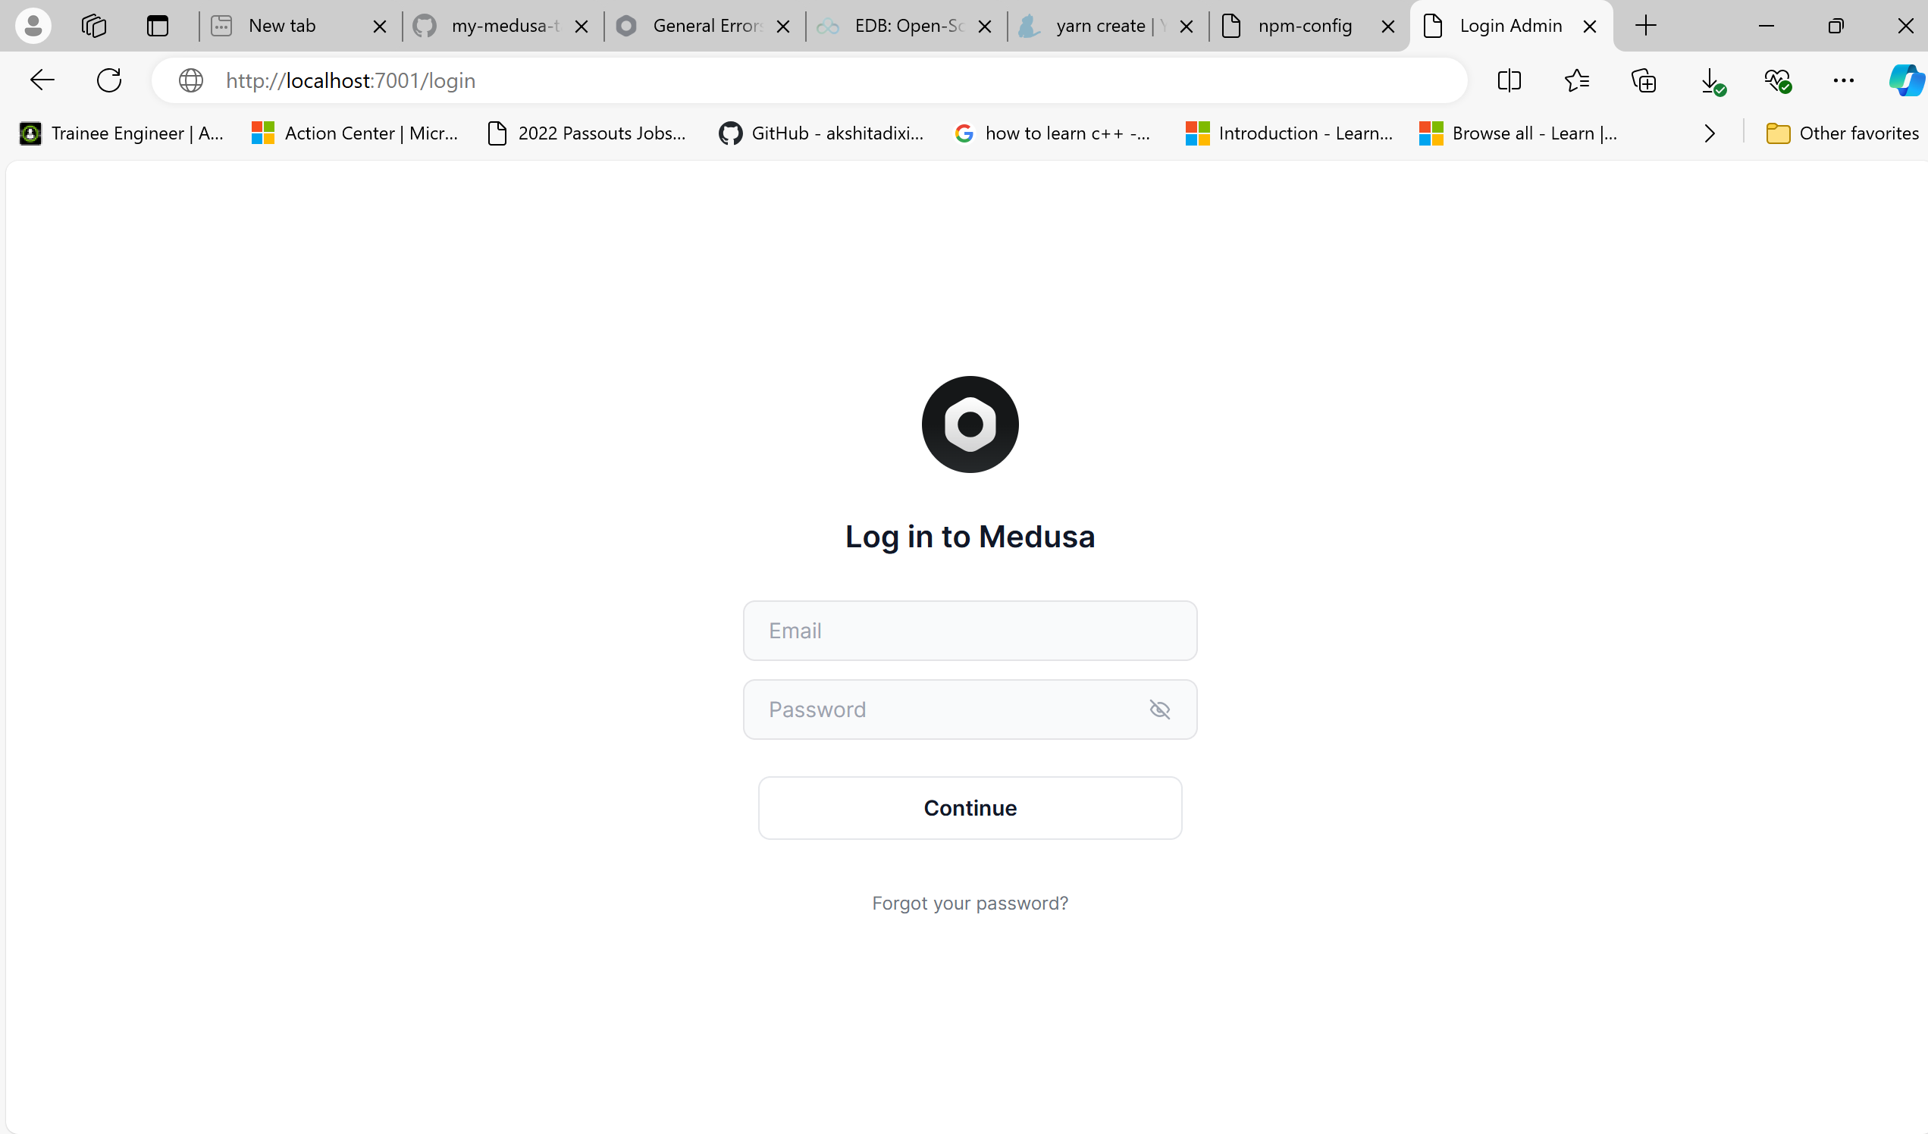

Adding the code into your github repository

GitHub Repository Setup

1. Initialize Git Repository:

- Command: `git init`

2. Add Files and Commit:

- Command: `git add .`

- Command: `git commit -m "Initial commit of Medusa project"`

3. Create GitHub Repository:

- Create a new repository on GitHub and copy the repository URL.

4. Add Remote and Push:

- Command: `git remote add origin <your-repo-url>`

- Command: `git branch -M main`

- Command: `git push -u origin main`